Parent Signature _________________________

Name__________________ Date_________________

**Study Guide: Midwest Region**

**Midwest Region Test Date: __________________________**

**What to Study:**

* 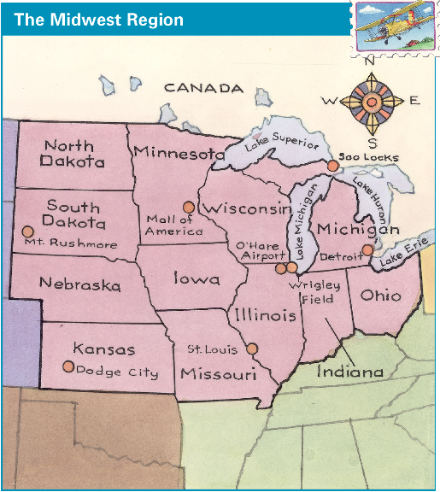Study the questions you answered on your organizer or in Seesaw during our Midwest tour.
* The notes below
* Reread Chapter 8 in TCI online and quiz yourself on the vocabulary cards.

**Resources**

* Social Studies Ch. 8 Midwest vocabulary organizer
* Chapter 8 in the Social Studies textbook and TCI online: The website is a great resource to help you study! On it you will find textbook pages, notecards, and a practice quiz!

**Midwest Region**

**St. Louis, Missouri:** Gateway Arch built to honor pioneers who first settled the west. St. Louis known as “Gateway to the West.”

**Iowa:** farm state – flat, fertile land produces huge crops of corn. Iowa lies between Mississippi & Missouri rivers

**Dodge City, Kansas:** famous for wheat and cowboys

**Black Hills, South Dakota:** Mount Rushmore honors presidents Washington, Jefferson, Lincoln, and Roosevelt. The Crazy Horse Memorial honors a chief of the Sioux tribe.

**Soo Locks, Michigan:** raise and lower ships between different water levels of Lake Huron and Lake Superior.

**Detroit, Michigan:** Henry Ford used an assembly line to make cars quicker so cars were less expensive; many women worked in factories in Detroit during WW II to help make tanks & planes for war.

**Chicago, Illinois:** Wrigley Field – 2nd oldest ballpark in America; O’Hare – transportation hub.

**Mall of America, Minnesota:**  largest indoor shopping mall in U.S.; indoor activities popular in Midwest because of cold & blizzards

